FOR IMMEDIATE RELEASE

CONTACT: Ed Poole
Hollywood on the Bayou
Gretna, LA
(504) 298-5267 ~ edp@HollywoodOnTheBayou.com

Louisiana Film History
The First Hundred Years
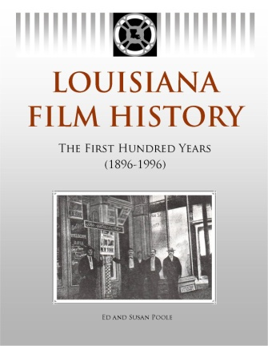
July 30, 2012 - GRETNA, LA - Louisiana Film History - The First Hundred Years is the first complete history of the introduction and development of the film industry in Louisiana. Take a glimpse at the birth of the cinema, its early struggles, and its almost immediate introduction to Louisiana. For the first time, details are presented to show the major influence Louisiana has had on the film industry since its first inception.

Read how some of America’s earliest film studios came to Louisiana -- even before they reached Hollywood. Learn about some of Louisiana’s homegrown filmmakers and their impact on the industry. Glance behind the scenes to learn more about how Louisiana’s fictional film characters came to life on the silver screen. Take a look at how Louisiana’s diverse ethnic heritage, including African, Cajun, Creole, French, German, Irish, Islenos, Native American, Spanish and West Indian, provided an unending source of inspiration for filmmakers. Stroll through the genres and topics as only Louisiana can present them: voodoo, above ground cemeteries, Mardi Gras, zydeco, cajun living, THEN you will begin to understand WHY Louisiana is called “Hollywood on the Bayou.”
Louisiana Film History is a companion book to Hollywood on the Bayou (HOB), released in April of 2011. HOB was presented in a listing fashion, documenting basic information on the the over 1100 films made in or about Louisiana. Louisiana Film History, on the other hand, tells the story of filmmaking in Louisiana. It is based on historical information gathered by the authors through years of research through newspapers, trade magazines and press materials of the day.
Louisiana is now third in the country in film production, behind only California and New York. Both California and New York have a tremendous amount of research facilities. It’s TIME for Louisiana to REMEMBER their film history.
Authors Ed and Susan Poole are film accessory researchers that have been in the industry for over 30 years. This is their 13th industry related reference book. The Pooles are on a quest to make sure that Louisiana’s film history is recorded and available throughout the state and not forgotten.
For additional information or to schedule an interview, please contact Ed Poole at (504) 298-5267 or visit the website www.HollywoodOnTheBayou.com.

Title: Louisiana Film History, The First Hundred Years
Authors: Ed and Susan Poole
Specs: ISBN 978-0-9815695-3-6 ~ 200 pages, 8.5” x 11” ~ Trade Paperback - $19.95
Publication date: August 1, 2012
###

